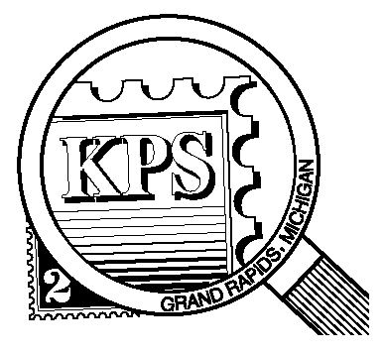

NEWSLETTER OF THE KENT PHILATELIC SOCIETY
P.O. Box 1156, Grand Rapids, Michigan 49501-1156
Louis Morel, President and Editor 269-420-3128
KentPhilatelicSociety.com
kps.stampclub@gmail.com

K.P.S. Philatelist
Volume 70- No. 9 September 2026

KPS Club News
The annual Kent Philatelic Society stamp exhibition and dealer bourse (KENTPEX) is just around the corner. The two-day event will take place once again at the Neal Fonger American Legion Post #179. It is located at 2327 Wilson Ave. SW. in Walker. Seven dealers will be on hand on Saturday, October 24 (10 AM to 4 PM) and Sunday, October 25 (10 AM to 3 PM). A stamp show presents an excellent opportunity for collectors to expand their collections. In addition, it is an opportunity for collectors to show their interests in unique exhibits. Send an email to kps.stampclub@gmail.com to indicate that you wish to exhibit at KENTPEX 2026. The show chairperson, Darrin Lettinga, will provide you with a registration form and instructions.  The exhibitor of the “best of show” as determined by popular vote, will receive a plaque, a medal, and a certificate. Second and third place finishers will also receive a medal and a certificate.  We will need volunteers to spend one hour or two at the registration desk to greet members and other collectors during the event. We will also need volunteers to help with set up on Friday evening for about one hour. You can sign up at this month’s meeting or contact Darrin by email at the aforementioned address. | Our thanks to Darrin Lettinga for his presentation on collecting a stamp series or making a collection from a single stamp: He used definitives from Ghana as a working example that can be applied to a variety of situations.  Club member and local dealer, Chris Daly, will host this month’s auction. He is offering a wide variety of stamps from all continents except Antarctica!  KPS Archives: Bay City was the home of the Essex County Philatelic Society in 1960. Thx KPS Philatelist reported that at the Essex County annual Stamp Show there were 109 frames exhibiting topics such as scouting, Presidents who were Masons, the Presidential series of 1938 in position plate blocks of each denomination, a Vatican display of First Day covers accompanied by mint and canceled stamps, the United States and Canada St. Lawrence Seaway, Alaskan statehood and 19th century First Day covers and postal cards. The latter made up about one third of the frames exhibited. The Post Office Department provided a Hi-Way Postal Station open to visitors for their inspection. A postal employee commented that “there were ten routes in Michigan of the Hi-Way Postal Station”.
The KPS Board will enhance our monthly auctions by holding a drawing for a FREE $10 certificate toward the winning purchases of one lucky member. You need to be present to participate in the drawing.

MONTHLY PROGRAM SCHEDULE
September 22, 2026: KPS CLUB MEETING  5:30 PM Board Meeting  6:15 PM Lot Viewing  7:00 PM Dealer Auction: Chris Daly | October 27, 2026: KPS CLUB MEETING  5:30 PM Board Meeting  6:00 PM Lot Viewing  6:45 PM Presentation and Donation Auction
The Kent Philatelic Society meets on the 4th Tuesday of the month at the Byron Center Baptist Church, 7343 Byron Center Ave SW, Byron Center.

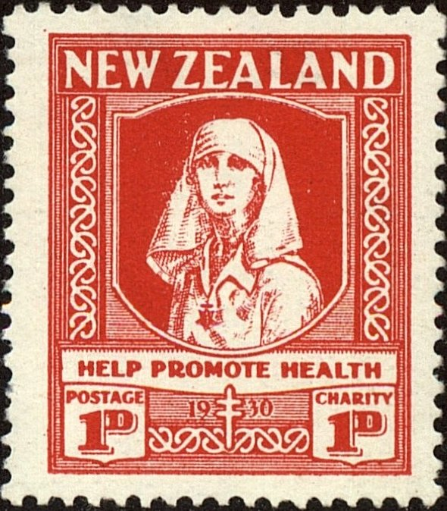
Members are invited to share their philatelic experiences in this space. Perhaps you made a special acquisition, or thrive on an uncommon collecting topic, or saw a remarkable exhibit. Share it with your fellow collectors. Contact the Editor with your stories.
There’s a Back to This Book?
Many collectors focus their attention on the definitives and commemoratives issued by the postal administrations of the world. These make up the bulk of the stamps issued by any given country. They are listed first in stamp catalogues. Behind them lies a trove of interesting and collectible stamps in the section referred to as the back-of-the-book.

These stamps typically have one or two letters as a prefix before the catalogue number. Learning what each prefix denotes is helpful knowledge when preparing a wish list or buying stamps. The Scott catalogues list back-of-the-book stamps with the following prefixes: AR for postal fiscal stamps, B for semi postal stamps, C for airmail stamps, E for special delivery stamps, J for postage due stamps, MR for war tax stamps, O for official stamps, P for newspaper stamps, UX for stamped envelopes and several more.

Argentina, for example, issued dedicated parcel post stamps in 2001. They were given the prefix Q. There are several other prefixes for other categories and sub categories.

Several countries have particular requirements. Japan, for example, has 47 political subdivisions called prefectures. There are 13 postal regions. Each region issues its own, stamps valid for postage throughout the country. These have the prefix Z.

The postal fiscal stamp stamps with the AR prefix are stamps that can be used for revenue purposes as well as for postage. The stamps’ denomination can pay for some governmental service, such as a deed.

Staying with New Zealand stamps as examples, the country’s first postal fiscal stamp was a two-shilling denomination bearing a portrait of Queen Victoria. It was issued in 1882. Mint revenue stamps can be much more difficult to find than used ones.

Semi postal stamps, have the prefix B in the catalog. They have a dual purpose. They cover the cost for carriage of mail and an additional fee, printed on the stamp, serves as a donation for charitable purpose.

New Zealand’s first semipostal was issued in 1929 to generate funds to fight tuberculosis. The very next year, the stamp was re-issued with a new inscription “Help Promote Health”. These stamps had a face value of two pence, half of which paid for postage and the remainder went to the charity.

Each of these stamps has a one penny denomination that paid for postage with an additional one penny added for the charity. Over time, the semipostal stamps of New Zealand were dedicated to raising money for children’s health, or to be more specific, for running children’s health camps. Today the funds are directed to organizations that provide many social services for children and families.

The most famous of New Zealand’s semipostals was an error stamp issued in 1996 that showed an infant in a car seat with a teddy bear strapped into the seat next to the baby. At the last minute, a decision was made to change the design by removing the teddy bear so that the baby did not appear to be facing forward, which broke safety rules.

The teddy bear stamps were withdrawn but some got into collectors’ hands because some post offices sold them in error. There are two varieties, one with water-activated gum and standard perforations (Scott B154), and another with self-adhesive gum and serpentine die cuts in place of perforations (Scott B155).

New Zealand has issued more than 200 semipostals, Belgium more than 1200, and the United States seven.

Many nations’ governments use Official stamps on their mail. The first Official stamp of New Zealand was issued in 1892. It was a standard postage stamp overprinted “O.P.S.O.” which stood for “On Public Service Only”. This meant they could only be used for government business. By 1907, the overprint read only “OFFICIAL”. In 1954, a new series of stamps specifically for Official use was designed. They featured a portrait of the newly-crowned Queen Elizabeth II.

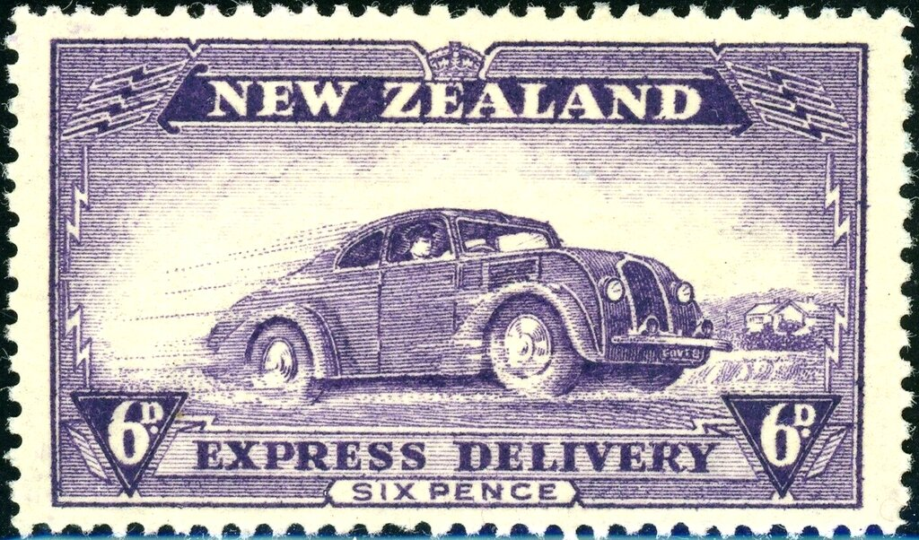
New Zealand only issued two special delivery stamps. The first one, a six pence denomination, was issued in 1903. The design relied more on text than on an image. It is significant that Maori carvings are found in the upper corners. The other special delivery stamp was issued in 1939. It shows a mail car (Scott E2) speeding down the road.

Clearly, there is much to discover in the “back-of-the-book”.

Louis Morel

